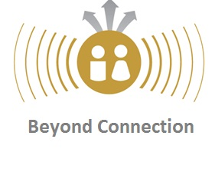 | BEYOND CONNECTION  Me & You in the Dynamics of Collaboration  Registration now open!

Introduction and approach
This course, beginning in September, consists of four workshops and four individual coaching sessions. In the course ‘Beyond Connection’ we focus on dynamics that are at play when people, groups or (project)teams meet and connect across disciplines within or outside our organisation. This course provides additions to the more rational and analytical capacities used when collaborating and aims to increase your effectivity and confidence in collaboration.

Practical information
Participants are required to attend all sessions. Each session will take place at Wageningen Campus. The course will be given in English or in Dutch depending on the demand and preference of the group participants.

Individual intake interview | June - August
Session 1 - Opening up and locate yourself | Tuesday 11 September, 13.00 – 17.00
Coaching session 1 | Appointment will be arranged in Sept/Oct
Session 2 - Dynamics and Trust | Tuesday 9 October, 13.00 – 17.00
Coaching session 2 | Appointment will be arranged in Oct/Nov
Session 3 - Network and connect | Tuesday 13 November, 13.00 – 17.00
Coaching session 3 | Appointment will be arranged in Nov/Dec
Session 4 - Project presentation | Tuesday 11 December, 13.00 – 17.00
Coaching session 4 | Appointment will be arranged after final session

Trainers
Dura Prins, trainer and coach at ‘Prins in Communicatie’, www.prinsincommunicatie.nl
Cor Meurs, Project Manager & trainer corporate Human Resources WUR

Outcome
- Insights in dynamics and alternative strategies that stimulate and enhance collaboration;
- An open mind-set, commitment and improved reflection skills for improved collaboration;
- Increased self-awareness and emotional intelligence that strengthens your position in your team, and facilitates a project or organisation in collaborations;
- Enhanced effectiveness in collaboration;
- New contacts and networks.

For more information: go to the intranet and search for Beyond Connection
For registration please contact: Ann-Marie Ryan, lend.chr@wur.nl

